

Teammatch, by SkillSwap team

─
Justin Kalski
Talin Keshesh
Sako Asatryan
BachViet
Zakir Rizvi

Problem Statement
In many computer science courses, students are assigned to project teams randomly or through informal self-selection. This frequently results in unbalanced teams where skill levels vary widely, schedules conflict, and workloads are unevenly distributed. Such mismatches can negatively affect learning outcomes, collaboration quality, and overall project success. In mixed-level classes containing juniors and seniors, these issues are further amplified, as inexperienced students may lack mentorship while experienced students may become overburdened. There is a need for a systematic, fair, and transparent way to form teams that balances skill levels and availability.

Proposed Solution
We propose TeamMatch, a web application that helps instructors form project teams in academic courses. The system collects student profiles that include technical skills, experience level, collaboration preferences, and weekly availability, along with an instructor-provided project description and basic team constraints. AI is used only to process and organize human-written information, such as converting free-text skill descriptions and project goals into structured data that the system can work with consistently. These AI-processed results are saved and reused so the system remains efficient and predictable.
Team assignments are created by a rule-based optimization engine, not by AI. This engine treats team formation as a constrained assignment problem and strictly enforces rules such as team size, enrollment boundaries, and instructor requirements. It then evaluates possible team combinations to balance skills, distribute experience evenly, and maximize overlapping availability for collaboration. After teams are finalized, AI is used again only to help explain the results by summarizing computed metrics and tradeoffs in clear language. This design keeps instructors in control, ensures results are repeatable and explainable, and uses AI as a supporting tool rather than the decision-maker.

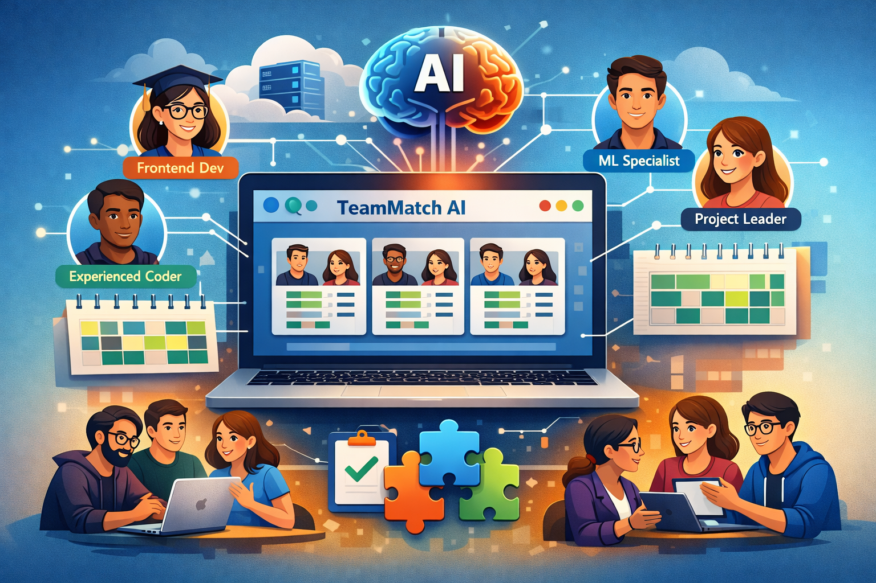

How it works
TeamMatch operates as a structured, multi-stage pipeline that separates data collection, AI-based processing, algorithmic optimization, and explanation generation. Each stage has clearly defined inputs and outputs, ensuring transparency and instructor control.

1. Data Collection and Inputs
The system begins by collecting information from two sources:
Student Inputs
- Self-described technical skills and experience level
- Preferred role on a team (e.g., frontend, backend, leadership)
- Weekly availability for collaboration
Instructor Inputs
- Project description and learning goals
- Desired team size and basic team constraints
These inputs include both structured fields (ratings, availability blocks) and unstructured text (skill descriptions and project goals).
Output of this stage:
Raw student and instructor data associated with a specific course.

2. Skill Representation and Normalization (AI-Assisted)
AI is used to process unstructured human input into a consistent format the system can work with. Student skill descriptions and instructor project goals are analyzed and converted into structured numerical representations aligned to predefined computer science skill categories (such as frontend, backend, machine learning, and systems).
This step resolves differences in how individuals describe their abilities and ensures that all students are evaluated using the same scale.
Inputs:
- Raw student skill descriptions
- Instructor project description
Outputs:
- Normalized student skill vectors
- Project-specific skill importance weights
These outputs are saved and reused, reducing repeated AI processing.

3. Scoring and Team Optimization (Non-AI Core)
Team formation is handled by a deterministic optimization engine that does not rely on AI. Using the normalized data, the system evaluates potential team combinations based on:
- Skill balance, to distribute experience evenly
- Schedule compatibility, based on overlapping availability
- Instructor-defined constraints, such as team size
A greedy matching algorithm with local improvements is used to form teams that maximize overall group quality while strictly enforcing all constraints.
Inputs:
- Normalized student skill vectors
- Availability data
- Team constraints
Outputs:
- Final team assignments
- Quantitative team quality scores
Because this process is rule-based, the same inputs always produce the same results.

4. Explainability and Output Generation (AI-Assisted)
After teams are finalized, AI is used in a limited post-processing role to generate clear, human-readable explanations. These explanations summarize the system’s computed metrics and describe why each team was formed, referencing factors such as complementary skills and shared availability.
Inputs:
- Final team assignments
- Computed team metrics
Outputs:
- Team formation explanations
- Instructor-facing summaries for review

Final System Outputs
- Balanced, constraint-satisfying project teams benefit both students and professors alike, creating more efficiently run classrooms and learning spurred more naturally from the balance of teams.
- Team-level metrics for skill coverage and availability
- Explainable summaries that support instructor review at how they could better improve

Technology Stack

Frontend
- Languages: HTML, CSS, JavaScript (or TypeScript)
- Frameworks: React / Vue + Tailwind CSS
- APIs: Calendar/availability UI, form validation, file upload (optional)
- Role: Student + instructor dashboards, skill/availability input, team results + explanations view

Backend
- Language: Python
- Framework: FastAPI
- Serverless Compute: AWS Lambda (API handlers)
- Role: Request routing, validation, business logic, calls to matching engine + AI services, reads/writes to database

Database / Services
- Database: AWS DynamoDB
- Storage: AWS S3 (exports, logs, optional uploads)
- Auth: AWS Cognito
- Role: User profiles, skill vectors, availability blocks, constraints, team results, audit/history

ML / APIs
- LLM API (Explainability + Parsing): OpenAI API or Amazon Bedrock
  - Convert project text + student text into structured skills/weights
  - Generate short “why this team” explanations
- Optional Embeddings: Bedrock embeddings (or OpenAI embeddings)
  - Semantic similarity for skills / project requirements
- Monitoring: CloudWatch logs/metrics for pipeline runs and model call costs

Microservice Agent
This is the “agent” she asked for
- Service Type: Agent Microservice (separate from main API)
- Runtime: AWS ECS Fargate
- Messaging: AWS SQS (job queue)
- Orchestration: AWS Step Functions (workflow)
- Role (Agent responsibilities)
  - Watches for a “Run Match” job
  - Pulls roster + project details
  - Calls LLM to compute project skill weights
  - Runs matching engine (greedy + local improvement)
  - Generates explainability text
  - Writes final teams + metrics back to DynamoDB
  - Sends completion status back to the main API/UI
Why this helps: your core API stays fast, while the “agent” handles longer workflows asynchronously like a real production system.

Deployment
- Frontend Hosting: AWS S3 + CloudFront
- Backend API: AWS API Gateway + Lambda
- Agent Service: ECS Fargate (containerized microservice)
- Secrets: AWS Secrets Manager (API keys)
- CI/CD: GitHub Actions → deploy to AWS (S3/Lambda/ECS)

Index
Firebase — Google backend platform offering Authentication, AWS DB, Storage, and hosting tools.
Firestore — NoSQL document database used to store profiles, availability, and team outputs.
Frontend — User-facing UI (here: Flutter web-first interface).
Backend — Server-side logic and APIs that store data, run matching, and enforce permissions.
Balanced teams — Teams formed to distribute experience/skills evenly and avoid overloading strong members.
Cloud Functions — Serverless back
end code (e.g., Firebase Functions) that runs on demand.

